**Classroom Management Video Demonstrations**

**Instructor’s Guide**

Last updated 1/27/2023

Dear Colleague,

The collection of brief video demonstrations or ‘episodes’ that accompany this guide depict common classroom management challenges. They are designed to help teachers develop their understanding of the range of classroom management issues that can arise and what they may look and sound like. By presenting contrasting teacher approaches, they are also designed to spark conversation about a range of management tactics that teachers can use and when each one might be more or less effective.

This guide contains information that supports your use of the episodes in professional development opportunities. The guide contains 4 sections: It is important to familiarize yourself with the contents of this guide prior to using the episodes.

1. **Episode Structure**

Each ~5-minute Episode contains the same essential elements presented in the following sequence:

1. **Introduction of a common classroom management challenge** (e.g., students asking to leave the room during academic work, students talking when they should be completing an assignment quietly, etc.)
2. **Presentation of a set of 3-4 potential responses to the challenge followed by the prompt, *“Which approach would you use?”***
3. **Demonstration of one potential option and its consequences,** *Let’s see what happens when the teacher tries Option X*. **This first video deliberately demonstrates a less successful approach.** Unsuccessful approaches are either: (1) an overly ***permissive*** strategy that fails to preserve time for teaching and learning or (2) an ***authoritarian*** or punitive approach that has negative consequences for student engagement in learning and/or the teacher-student relationship.
4. **Then, a second video demonstrates a more successful approach to the same challenge, Now let’s see what happens when the teacher tries option Y**. This video typically depicts the teacher’s use of ***firm control or authoritative management*** practices. This more effective approach balances teacher authority with meeting students’ needs.
5. Finally, **each episode concludes with the prompt, *“Which approach was more effective? Why?”*** This prompt asks viewers to compare the two approaches, noting their respective characteristics and likely impact. This comparison strategy draws from research on the power of ***contrasting cases*** as a tool for developing problem-solving strategies.

Repeated exposure to the challenges and demonstrated approaches should enrich teachers:

(1) definitions of classroom management and its two aims (a. preserving time for teaching and learning, and b. fostering student self-regulation),

(2) ability to **recognize** a range of classroom management approaches and their likely impact on students (Episode 15 is designed to directly test this expectation) , and

(3) ability to **intentionally choose** the classroom management approach that best fits their teaching style and their specific context. Consistent with this objective, the episodes deliberately avoid saying what teachers “should” do in a given situation.

1. ***Episode Guide***

This section outlines each challenge and the teacher’s contrasting approaches. It is the heart of this guide and is designed to support your ability to guide teachers’ noticing of the video contents.

**Episode 7: Managing Classroom Disruptions**: How can a teacher respond when students are talking when they should be working quietly?

**Four potential responses are provided** (see below). You may wish to stop the video here to engage teachers in a discussion of which approach is likely to be more effective and why. The goal is to foster teacher engagement by asking them to make a choice or a prediction about ‘best practice.’

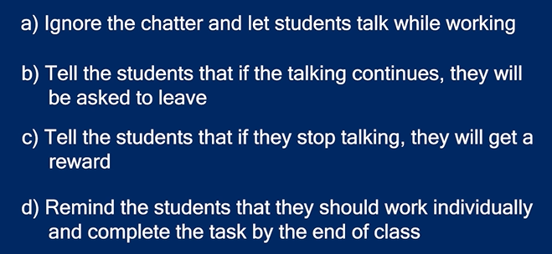

**Video 1:** The first (less effective) video portrays Option B, which is an Authoritarian stance. Authoritarian teaching style focuses on student compliance and punishment as a form of behavior management. While an authoritative approach can be effective in terms of efficiency and creating time for teaching and learning, too much of an authoritative style may result in student disengagement (Walker, 2008; Wentzel, 2002).

**Video 2:** The second (more effective) video portrays Option D, which is an Authoritative approach. An authoritative style also focuses on teacher authority; however, it balances teachers’ firm control with attention to students’ needs. Two key differences between Authoritative and Authoritarian teaching are: Authoritative teachers take time to explain the reasoning behind their directions and they tend to “assume the best and ask questions” when confronting students about their behavior.

**Comparing the two** **approaches: Key differences to point out and discuss.** You can support teachers’ understanding of these two classroom management styles by drawing their attention to several differences between the Authoritative (second) and Authoritarian (first) approaches. First, the Authoritative teacher begins with a request for students’ attention (vs. fussing at them with the remark, “Why do I hear so much talking?”). Second, rather than scolding students about their behavior, she reminds them about her expectations (e.g., “I just want to remind you that this is an independent assignment”). Moreover, she explains how their behavior relates to the current classroom goals (e.g., “I just want to remind you that there are only a few minutes left. Ask yourself, am I on track?...”).

Undoubtedly, teachers will notice a number of other differences between the two approaches including tone of voice and non-verbal communication. We encourage you to ask teachers about how they think these small differences relate to the overall management style.

**Episode 8: Managing Academic Work**. How can teachers respond when students challenge their organization of academic work? For example, they may challenge where they work and whom they work with.

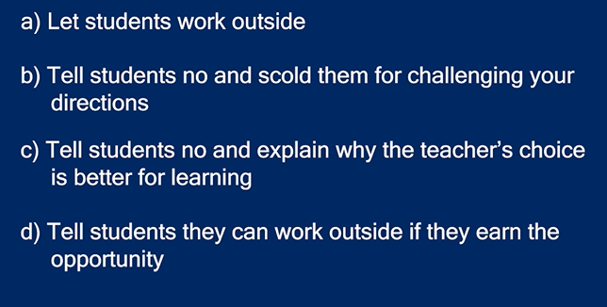

**Video 1:** The first (less effective) video portrays Option B, which is an Authoritarian stance. Authoritarian teaching style focuses on student compliance and punishment as a form of behavior management. While an authoritative approach can be effective in terms of efficiency and creating time for teaching and learning, too much of an authoritative style may result in student disengagement (Walker, 2008; Wentzel, 2002).

**Video 2:** The second (more effective) video portrays Option C, which is an Authoritative approach. An authoritative style balances teachers’ firm control with attention to students’ needs.

**Comparing the two** **approaches: Key differences to point out and discuss.** You can support teachers’ understanding of Authoritarian (first) and Authoritative (second) classroom management styles by drawing their attention to several differences between the approaches. First, Authoritative teachers take time to explain the reasoning behind their directions and they tend to “assume the best and ask questions” when confronting students about their behavior. Thus, while both approaches involves setting clear teacher expectations, the teachers’ “because I said so” response to a student’s question about how they’ll get the work done sets a coercive tone. As a result, her statement, “Does anybody else have any questions?” doesn’t elicit student engagement. Rather, it reinforces that she is in charge and that students need to get to work.

Second, rather than scolding students about their behavior, she reminds them about her expectations (e.g., “I just want to remind you that this is an independent assignment”). Moreover, she explains how their behavior relates to the current classroom goals (e.g., “I just want to remind you that there are only a few minutes left. Ask yourself, am I on track?...”).

Undoubtedly, teachers will notice a number of other differences between the two approaches including tone of voice and non-verbal communication. We encourage you to ask teachers about how they think these small differences relate to the overall management style.

**Episode 9: Managing Student Requests to Leave the Classroom:** How can teachers respond when a student wants to leave the classroom during academic work time? For example they may ask to go to the office or their locker during an instructional time

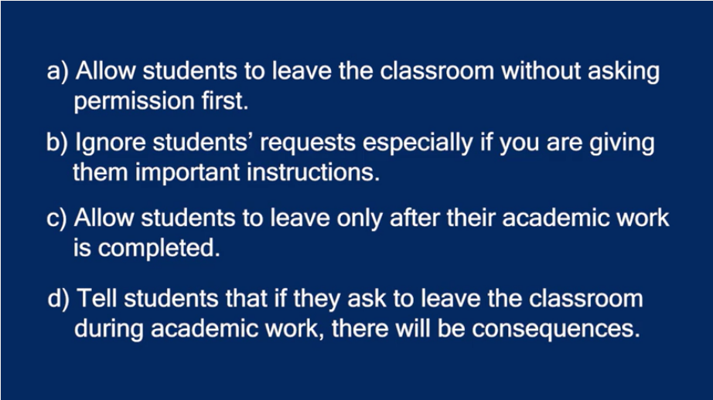

**Video 1:** The first (less effective) video portrays Option D, which is an Authoritarian teaching style focuses on student compliance and punishment as a form of behavior management. While an authoritative approach can be effective in terms of efficiency and creating time for teaching and learning, too much of an authoritative style may result in student disengagement (Walker, 2008; Wentzel, 2002).

**Video 2:** The second (more effective) video portrays Option C, allowing the student to leave only after their academic work is completed, which is an Authoritative approach. An authoritative style balances teachers’ firm control with attention to students’ needs. This response focuses on the learning and completing the work as contingent on being able to leave.

**Comparing the two** **approaches: Key differences to point out and discuss.** You can support teachers’ understanding of Authoritarian (first) and Authoritative (second) classroom management styles by drawing their attention to several differences between the approaches. Although both approaches involve setting clear teacher expectations, the first, Authoritarian teaching does not engage the student or build the student’s understanding of the rules or why a decision is made, the response of “You know the rules” doesn’t elicit student engagement or seeking to understand, rather, it reinforces that he is in charge and that students need to follow the rules without question.

Secondly, Authoritative teachers take time to explain the reasoning behind their requirements and they would explain to students the importance of learning and why they need to complete the academic work, providing value when confronting students about their behavior.

With an Authoritative style, rather than scolding students about their behavior, he reminds the student of the expectation for his classroom engagement (e.g., “I’m going to ask you to stick with me, get through this lab first”). Additionally, he reassures the student that he values her concern, and her needs will be met by validating what she deems important (e.g., “I guarantee your clothes will be safe in the office…once you finish your work, I’m going to let you go ahead and grab them”). Finally, the teacher seeks confirmation from the student that they are in agreement with the resolution, (e.g., “How does that sound?”), this will ensure that the challenging behavior will conclude as the student confirms she is satisfied with the outcome (e.g., “sounds good”).

It is expected that teachers will notice a number of other differences between the two approaches including tone of voice and non-verbal communication. We encourage you to ask teachers about how they think these small differences relate to the overall management style.

**Episode 10: Apologizing and resetting the tone;** What can you do if you “get off on the wrong foot” with your students? For example, a teacher may be very harsh when redirecting students and wants to reset the tone of the classroom.

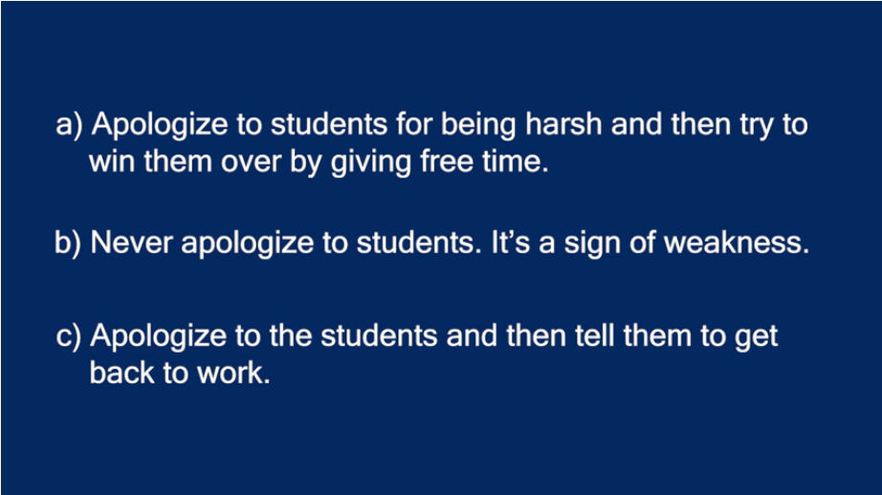

**Video 1:** The first (less effective) video portrays Option A, apologizing to students for being harsh and they try to win them over by giving free time, which is a Permissive teaching style focuses on student allowing students to be off task or being non-confrontational as a way to avoid behavior challenges from student. While a permissive approach can be effective in terms of avoiding a student outburst or confrontation, it also does not engage students with the academic tasks and does not set clear expectations for the classroom, long term this approach will cause the teacher to struggle with behavior management and mutual respect in the classroom.

**Video 2:** The second (more effective) video portrays Option C, apologize to the students and then tell them to get back to work, which is an Authoritative approach. An authoritative style balances teachers’ firm control with attention to students’ needs. This response focuses on expressing the awareness of teacher’s misstep without foregoing a level of classroom expectations. In this response the teacher is setting the tone of mutual respect.

**Comparing the two** **approaches: Key differences to point out and discuss.** You can support teachers’ understanding of Permissive (first) and Authoritative (second) classroom management styles by drawing their attention to several differences between the approaches. In the first approach, the Permissive teaching does not set expectations for students, and attempts to use gain control by offering a reward rather than collaboration and compromise (e.g., “IS everyone ok with a little bit of free time?”). A permissive style focuses on being well-liked as opposed to respected.

Secondly, Authoritative teachers take time to explain the reasoning behind their requirements and they would explain to students the importance of apologizing while maintain expectations. Here the teacher is providing empathy for their misstep while maintaining control .

It is expected that teachers will notice a number of other differences between the two approaches including tone of voice and non-verbal communication. We encourage you to ask teachers about how they think these small differences relate to the overall management style.

**Episode 11: Managing Peer Interactions:** What can you do when students are unkind towards one another in the classroom? For example, students might make comments about another students during academic work.

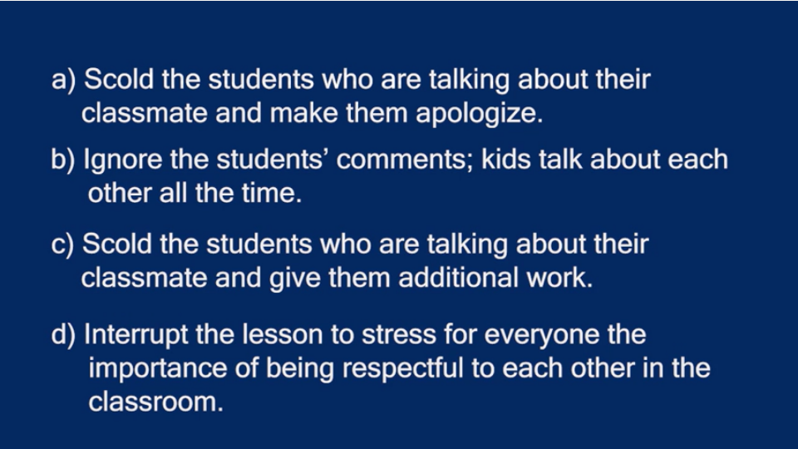

**Video 1:** The first (less effective) video portrays Option B, ignoring the students’ comments; with the ideal that kids talk about each other all the time, which is a Permissive teaching style focuses on student allowing students to bully or degrade one another. While a permissive approach can be effective in terms of avoiding a student outburst or confrontation, it also allows the students behavior to go uncorrected, and will likely result in the behavior continuing and the results will set a tone in the classroom that this type of behavior is acceptable. It is also allowing for the targeted student to be disenfranchised and a trusted adult is not interceding.

**Video 2:** The second (more effective) video portrays Option D, interrupts the lesson to stress for everyone the importance of being respectful to each other in the classroom, which is an Authoritative approach. An authoritative style balances teachers’ firm control with attention to students’ needs. This response focuses on using this situation as an opportunity to talk to the class about respect. Initially the teacher does not call out the students words explicitly, rather hoping that addressing their general talking during silence work would alert them that he is listening. However, when the situation escalates, teacher’s response is setting the tone of mutual respect as an important component in the classroom community they are all part of.

**Comparing the two** **approaches: Key differences to point out and discuss.** You can support teachers’ understanding of Permissive (first) and Authoritative (second) classroom management styles by drawing their attention to several differences between the approaches. In the first approach, the Permissive teaching does not set expectations for students, and ignores the students remarks about their classmates (e.g., “Even Mr. Charles isn’t saying anything” ). A permissive style here focuses on being non-confrontational instead of setting the tone for respect in the classroom for one another.

Secondly, Authoritative teachers take time to explain why their actions are hurting someone else. By asking the students to evoke empathy, (e.g., “How do you think you would feel..”) the students are given an opportunity to self-reflect on their actions. Additionally, with an authoritative teaching style, the teacher is guiding the students towards an awareness of others, rather than simply telling them not to do something. Finally, rather than issuing a punishment for their behavior, the teacher is offering the opportunity to continue the discussion and answer questions after the academic work is completed.

It is expected that teachers will notice a number of other differences between the two approaches including tone of voice and non-verbal communication. We encourage you to ask teachers about how they think these small differences relate to the overall management style.

**Episode 12: Managing Students Who Finish an Assignment Early:** How can you address when a student finishes an assignment before their peers. For example, how can you direct a student while they wait for their classmates to finish the classwork?

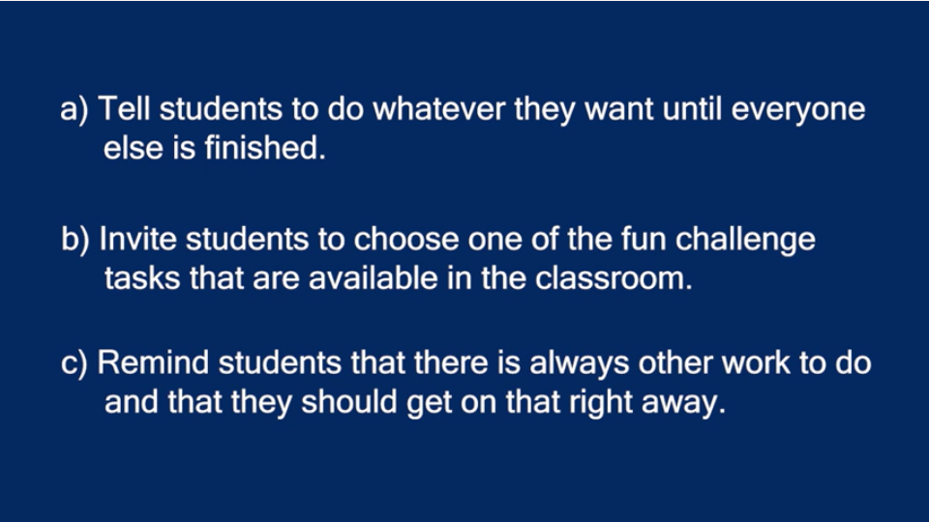

**Video 1:** The first (less effective) video portrays Option C, remind students that there is always other work to do and that they should get on that right away, which is an Authoritarian teaching style focuses on student compliance and punishment as a form of behavior management. While an authoritative approach can be effective in terms of efficiency and creating time for teaching and learning, too much of an authoritative style may result in student disengagement (Walker, 2008; Wentzel, 2002).

**Video 2:** The second (more effective) video portrays Option B, invite students to choose one of the fun challenge tasks that are available in the classroom, which is an Authoritative approach. An authoritative style balances teachers’ firm control with attention to students’ needs. This response focuses on using this situation as an opportunity to have students engage with an enrichment opportunity and avoids the student completing tasks not related to the academic work or distracting other students still working.

**Alternative:** The alternative video portrays Option A, tell students to do whatever they want until everyone else is finished, which is a Permissive approach which focuses on avoiding conflict over maintaining a classroom expectation. While, a permissive approach may have students perceive the teacher as a friend, this focus on popularity over order in the classroom have the potential to make classroom management a challenge for the larger group.

**Comparing the two** **approaches: Key differences to point out and discuss.** You can support teachers’ understanding of Authoritarian (first) and Authoritative (second) classroom management styles by drawing their attention to several differences between the approaches. In the first approach, the Authoritarian teaching approach does not engage the student in a meaningful task or address the student’s interests following the completion of their work. (e.g., “Matter there at least 3 assignments you didn’t finish” ). Also, the Authoritarian teaching style asserts the teacher’s power in the classroom setting by reminding the student what they are and are not permitted to do. (“No, you can’t take a nap in my classroom”). This approach completely dismisses the students feelings and asserts the teacher’s control over her actions.

Secondly, Authoritative teachers take time to explain why a challenge task is a better use of time and will be engaging. This approach begins by validating the students request before offering a more school appropriate alternative. (“I do understand that you’re exhausted, but…”). This approach establishes a culture of empathy and support while maintaining a firm expectation in the classroom. The authoritative approach allows the teacher to validate the student while explaining why a nap would not be ideal during class time while others are working.

For the Alternative video, a Permissive approach, allowing students to do what they choose without parameters invites other students to attempt “taking advantage” and wanting to go off task without being finished with their work. (“Wow, can I take out my phone too?”)

It is expected that teachers will notice a number of other differences between the two approaches including tone of voice and non-verbal communication. We encourage you to ask teachers about how they think these small differences relate to the overall management style.

**Episode 13: Managing Student Engagement:** How can you keep students engaged during academic work? Sometimes students are not engaged in an academic task. For example they might fall asleep during instruction.

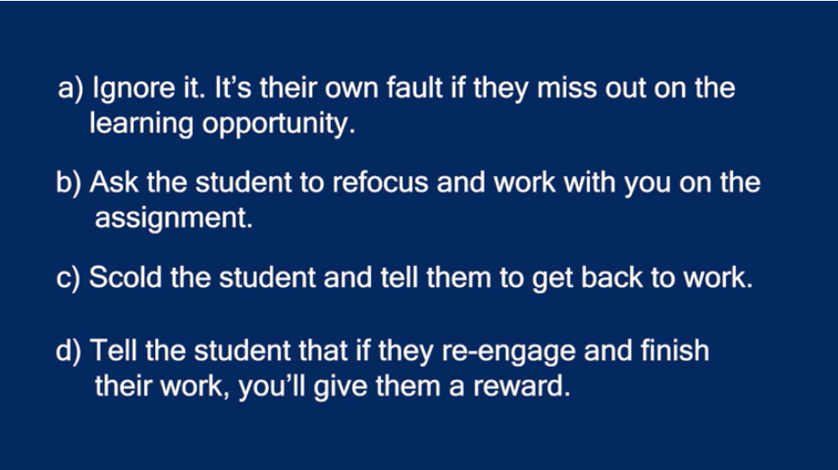

**Video 1:** The first (less effective) video portrays Option C, Scold the student and tell them to get back to work, which is an Authoritarian teaching style focuses on student compliance and punishment as a form of behavior management. While an authoritative approach can be effective in terms having students complying with instruction, too much of an authoritative style may result in student disengagement (Walker, 2008; Wentzel, 2002). Additionally, it will not address the reason for the student’s initial disengagement.

**Video 2:** The second (more effective) video portrays Option B, Ask the student to refocus and work with you on the assignment, which is an Authoritative approach. An authoritative style balances teachers’ firm control with attention to students’ needs. This response focuses on using this situation as an opportunity to have students engage with an opportunity to show compassion for a student struggling to engage in the academic task, inviting the student to move around and avoid disengaging with a nap.

**Comparing the two** **approaches: Key differences to point out and discuss.** You can support teachers’ understanding of Authoritarian (first) and Authoritative (second) classroom management styles by drawing their attention to several differences between the approaches. In the first approach, the Authoritarian teaching approach does not show compassion for the students struggle and calls the student out without giving her the opportunity to express herself or explain why she fell asleep. (e.g., “I don’t care if your were ticking and tocking last night, you need to stay awake” ). Also, the Authoritarian teaching style asserts the teacher’s power in the classroom setting by reminding the student what they are and are not permitted to do. (“I need you to stay awake in class, everybody else is working”). This approach completely dismisses the students feelings and asserts the teacher’s control over her actions.

Secondly, Authoritative teachers take time to address the students immediate needs. The teacher provides an opportunity for her to re-engage by approaching her discretely and offering strategies to wake up. This approach begins by immediately validating her apology. (“It’s alright, I see that you’re a little bit tired”). This approach establishes a culture of empathy and support while maintaining a firm expectation in the classroom. The authoritative approach allows the teacher to validate the student while offering her the opportunity to take a little walk and them return and work with the teacher to stay focuses.

It is expected that teachers will notice a number of other differences between the two approaches including tone of voice and non-verbal communication. We encourage you to ask teachers about how they think these small differences relate to the overall management style.

**Episode 14: Getting to Know Students and their Names:** Taking attendance by calling a roll is a good way to meeting students and learn their names, What do you do when you do not say a student’s name correctly? For example you may mispronounce a student’s name?

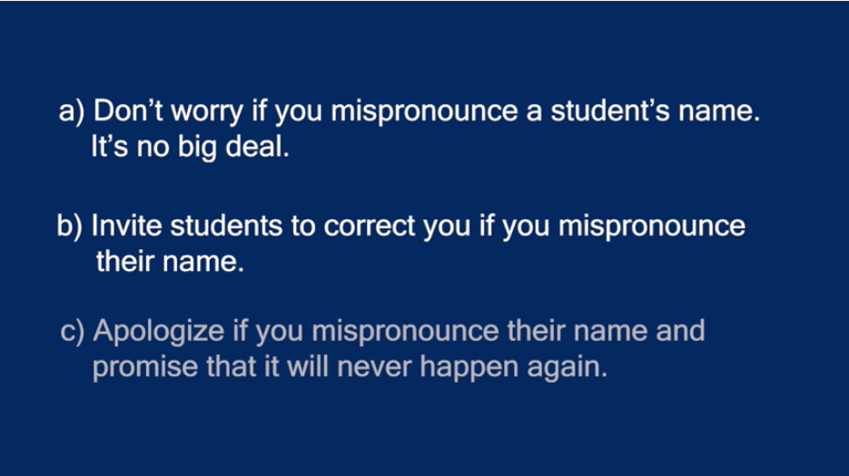

**Video 1:** The first (less effective) video portrays Option A, Don’t worry if you mispronounce a student’s name. It’s no big deal, which is a Dismissive and Authoritarian style which focuses on getting to the objective of the teachers task above students feelings or input being considered. This type of teaching style does not allow for the teacher to pause to take into considerations how students are receiving information and focuses solely of completing the task at hand. This style can result in students becoming disengaged in what the teacher is saying.

**Video 2:** The second (more effective) video portrays Option B, Invite students to correct you if you mispronounce their name, which is an Authoritative approach. An authoritative style balances teachers’ firm control with attention to students’ needs. This response focuses on using this situation as an opportunity to show students that the teacher can make mistakes and that openness to correction is important. This style creates an inviting classroom environment in which students are validated and are able to respectfully correct the teachers’ mispronunciation.

**Comparing the two** **approaches: Key differences to point out and discuss.** You can support teachers’ understanding of Dismissive Authoritarian (first) and Authoritative (second) classroom management styles by drawing their attention to several differences between the approaches. In the first approach, the Dismissive Authoritarian teaching approach does not show sensitivity to students’ names and does not create an environment receptive to feedback. (e.g., “Same thing….Ok Ethan, but you know I was talking to you” ). Also, the Dismissive Authoritarian teaching style asserts the teacher’s power in the classroom setting and the teacher does not allow the student to express their concern by continuing with the next task without validating their feelings or acknowledging the teachers mistake.

Secondly, Authoritative teachers take time to address the mistake as well as inviting students to respectfully correct any mispronunciations. The teacher provides an opportunity for the student to both correct the pronunciation as well as explain why it is important for them to use both names. This approach begins by setting the tone immediately for feedback. (“If I make a mistake, please do not hesitate to let me know”). This approach establishes a culture of mutual respect and a firm expectation in the classroom. The authoritative approach allows the teacher to validate the student while offering him the opportunity to correct her, without taking too much time away from the task of taking attendance.

It is expected that teachers will notice a number of other differences between the two approaches including tone of voice and non-verbal communication. We encourage you to ask teachers about how they think these small differences relate to the overall management style.

**Episode 15: Managing student resistance to starting an Academic Task:** What do you do if your students are hesitate to engage in a task. For example they do not start an academic task when directed.

You arrive to school to find you will be in Mr. Flynn’s Biology class today, and he has prepared a lesson and lab for your lesson. When the students arrive for 3rd period some are surprised to learn you will be teaching an active lesson and lab today, a few students express their disapproval… Given biology isn’t your own strongest content area you are very worried how the rest of the day will go.

You’re a sub, sub-days are supposed to be easy, come on where’s our packet? I’m tired I just want to put my head down, you’re not a “real teacher” anyway why do you care?, this sucks, I was planning on doing homework for next period.

How do you respond?

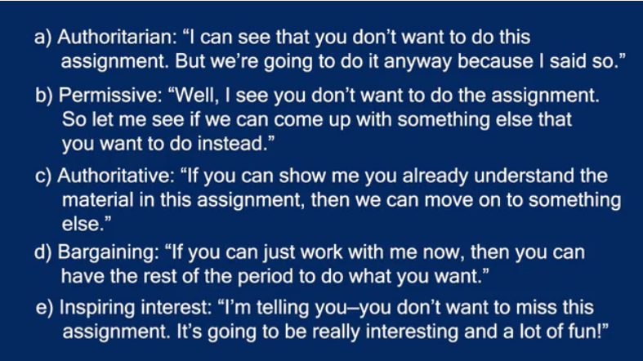

**Video 1:** The first (less effective) video portrays Option A, Video 1: **Authoritarian style**,” I can see that you don’t want to do this assignment. But we’re going to do it anyway because I said so”. An Authoritarian teaching style focuses on student compliance and punishment as a form of behavior management. While an authoritative approach can be effective in terms of efficiency and creating time for teaching and learning, too much of an authoritative style may result in student disengagement (Walker, 2008; Wentzel, 2002). This type of teaching style does not evidence to the students why the academic task is important and worthwhile for them, and it is likely the students will not engage with the work.

**Video 2:** The second video portrays Option B, **Permissive,** “Well, I see you don’t want to do the assignment. So let me if I can come up with something else that you want to do instead”. A permissive teaching style focuses on allowing students to be off task or being non-confrontational to avoid behavior challenges from student. This approach of being well liked trumps being effective at engaging students in the task. While a permissive approach can be effective in terms of avoiding a student outburst or confrontation, it also does not engage students with the academic tasks and does not set clear expectations for the classroom, long term this approach will cause the teacher to struggle with behavior management and mutual respect in the classroom. The teachers lack of firm control in the classroom may result in the students taking advantage of their desire to be liked.

**Video 3:** The third video portrays Option C, **Authoritative,** “If you can show me you already know understand the material in this assignment, then we can move onto something else”. An Authoritative teaching style balances teachers’ firm control while addresses students wants and needs. While the teacher does acknowledge that the students may not want to complete the assigned tasks, she is able to maintain firm control in the clear and redirects them to their wants if they can demonstrate an understanding of the assigned work with a quiz. This approach allows the students voices to be heard while maintaining a level of expectation that the students must ultimately know and understand this material, once they do, they can move on to a new engaging task.

**Video 4:** The fourth video portrays Option D, **Bargaining,** “If you can just work with me now, then you can have the rest of the period to do what you want”. A Bargaining style focuses on completing the task, using the motivation of getting something if you do this first. This style of teaching can be helpful in situations where there is a danger or consequence to the student if they cannot complete the assigned task. For example, leaving the classroom for a fire or drill.

**Video 5:** The fifth video portrays Option E, **Inspiring Interest,** “I’m tell you-you don’t want to miss this assignment. It’s going to be really interesting and fun” An Inspiring Interests style of teaching using students own interests and background as a motivation to engage students and build excitement for learning the material. This style of teaching focuses on students developing their knowledge and understand and interest by connecting the material to their own lives. This style of teaching can be effective when first introducing a topic or new task that might notbe immediately engaging or interesting based on it’s content or context.

It is expected that teachers will notice a number of other differences between the two approaches including tone of voice and non-verbal communication. We encourage you to ask teachers about how they think these small differences relate to the overall management style.

1. ***Glossary of Essential Terms***

* ***Authoritarian***
* ***Authoritative***
* ***Firm Control***
* ***Permissive***
* ***Contrasting cases***
* ***Classroom management***

***Note:*** *While these approaches portray effective and less effective behaviors based on the students’ reactions, these approaches are not in themselves good or bad. Given the situation, they can each be appropriate. For example,*

***Authoritarian:*** *Safety, when time/urgency matters*

***Authoritative:*** *Teachable moments, this approach has been shown to be particularly necessary when starting new routines and establishing relationships*

***Permissive: when expectations need to be adjusted, when the how is less important than the what, …***

1. ***Strategies for Using the Video Demonstrations***
   1. ***Whole group discussion: pause to consider which is best and why; what would be the consequences; which should be more effective and why?***
   2. ***How did the teacher’s behavior impact the situation? How did the student’s behavior impact the situation?***
   3. ***Breakout rooms; What would you do? Which one do you think is the most effective? How do you think the students would respond?***
   4. ***Reflection prompts: What did you learn today? About yourself? About classroom management? Which response produced the best response?***
   5. ***Looking at this range of options, which ones do you feel are most comfortable or not for you? How would you characterize your current management style? What goals do you have for yourself as a classroom manager?***
   6. ***Design your own episode; Role play***
   7. ***Having participants reflect on the task in a small groups and determine next steps before returning to he large group with a plan of approach.***

***Appendix: The Research Underlying the Episodes’ Structure***

The contrasting qualities of teachers’ management approaches (i.e., permissive, authoritarian and authoritative) are grounded in research that draws from parenting style and its impact on students’ cognitive and social development. Citations for research that informed the episodes’ design are:

Kersting, N. B., Smith, J. E., & Vezino, B. (2021). Using authentic video clips of classroom instruction to capture teachers’ moment-to-moment perceiving as knowledge-filtered noticing. *ZDM–Mathematics Education*, *53*(1), 109-118.

Loibl, K., Tillema, M., Rummel, N., & van Gog, T. (2020). The effect of contrasting cases during problem solving prior to and after instruction. *Instructional Science*, *48*(2), 115-136.

Pankowski, J., & Walker, J.M.T. (2016). Using simulation to support novice teachers’ classroom management knowledge and skills: Comparing traditional and alternative certification groups. *Journal of the National Association for Alternative Certification, 11*(1), 3-20.

Roelle, J., & Berthold, K. (2015). Effects of comparing contrasting cases on learning from subsequent explanations. *Cognition and Instruction*, *33*(3), 199-225.

Schwartz, D. L., Chase, C. C., Oppezzo, M. A., & Chin, D. B. (2011). Practicing versus inventing with contrasting cases: The effects of telling first on learning and transfer. *Journal of educational psychology*, *103*(4), 759.

Sherin, M. G., & Russ, R. S. (2014). Teacher noticing via video: The role of interpretive frames. In *Digital video for teacher education* (pp. 11-28). Routledge.

Walker, J.M.T., & Dotger, B.H. (2012). Because wisdom can’t be told: Using comparison of simulated parent-teacher conferences to assess prospective educators’ interpersonal skills. *Journal of Teacher Education. 63*(1), 62-75.

Walker, J.M.T. (2009). Authoritative classroom management: How control and nurturance work together. In J. Walker (Ed.) A person-centered approach to classroom management: How and why it makes a difference. *Theory Into Practice*, *48*(2), 122-129.

Walker, J.M.T. (2008). Looking at teacher practices through the lens of parenting style: Three case studies at entry to middle school. *Journal of Experimental Education, 76,* 218-240.

Walker, J.M.T. (2016) *Family Engagement Mini-Course*, an open source online professional development course developed for the *Council on the Accreditation of Educator Preparation (CAEP)*, Washington D.C. Available at <http://www.caepfamilyengagement.org/>

Wentzel, K. R. (2002). Are effective teachers like good parents? Teaching styles and student adjustment in early adolescence. *Child development*, *73*(1), 287-301.